**Activity Sheet Answers**

**Chapter 5, Lesson 6**

**Does Temperature Affect Dissolving?**

***INTRODUCTION***

1. Does the temperature of water affect the amount of coating that dissolves from an M&M? Talk with your group and design an experiment to find out. List three variables and how you will control them. What is the only variable that should be changed?

Answers will vary by group but should include variables like: amount of water, position of M&M in the container, timing, etc. The only variable that should be changed is the temperature of the water.

***ACTIVITY***

1. Does the temperature of the water affect the amount of coating that dissolves from an M&M? How do you know?

Yes, water temperature affects the amount of coating that dissolves from an M&M. More candy shell dissolves at a higher temperature.

***EXPLAIN IT WITH ATOMS & MOLECULES***

1. What are the differences in the way water molecules move in cold, room temperature, and hot water?

Water molecules move faster in hot water than they do in room-temperature or cold water. Molecular motion increases as the temperature of a liquid increases.

1. On the molecular level, why do you think sugar dissolves better in hot water than in cold water?

Sugar dissolves better in hot water than in cold water because of the extra energy of the sugar molecules and water molecules in hot water. When sugar is in hot water, its molecules move faster, and so do the water molecules. This increased movement means that sugar molecules have more energy and when water molecules associate with individual sucrose molecules, they can more easily overcome the attraction that sucrose molecules have for one another.

1. Why do you think there is a greater difference in the amount of dissolving between the hot and room temperature water than between the room temperature and cold water?

There is a greater difference in the amount of dissolving between hot and room-temperature water than there is between room-temperature and cold water because there is a greater difference in temperature between hot and room-temperature water, and therefore, a greater difference in the energy of the molecules.

***DEMONSTRATION***

1. Your teacher showed you an activity comparing the amount of salt that can dissolve in hot and cold water and the amount of sugar that can dissolve in hot and cold water. Just like in your M&M experiment, much more sugar dissolved in hot water. Does much more salt dissolve in hot water than in cold? How do you know?

No, the amount of salt that dissolved in hot and cold water was about the same.

1. 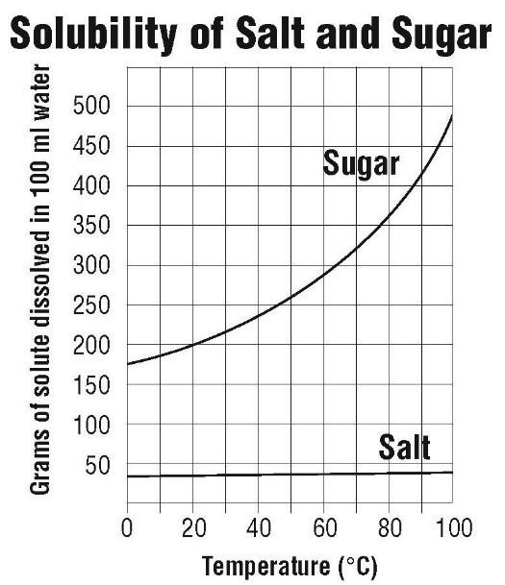The following data table and graph compare how much sugar and salt can dissolve in water over the temperature range 0 °C to 100 °C. Use the table and graph to answer the following questions.

|  |  |  |  |  |  |  |
| --- | --- | --- | --- | --- | --- | --- |
| **Solubility of sodium chloride and sucrose**  Measured in grams of solute dissolved in 100 mL of water | | | | | | |
| Temp. °C | 0 | 20 | 40 | 60 | 80 | 100 |
| Sodium chloride | 35.5 | 36 | 36.5 | 37.5 | 38 | 39 |
| Sucrose | 179 | 204 | 241 | 288 | 363 | 487 |

The activity showed that temperature affects the dissolving of sugar more than it affects the dissolving of salt. Explain how the graph shows this.

The graph shows the amount of sugar and salt that dissolve over a temperature range of 0–100 °C. Over that range, the values for the amount of sugar that dissolves increase, going up along the y-axis. But the values for the amount of salt that dissolves increases only slightly, as shown by the line with a slight increase up the y axis.

How much sugar dissolves in 100 mL of water at 50 °C?  
About 260 g of sugar will dissolve in 100 mL of water at 50 °C.   
  
How much salt dissolves in 100 mL of water at 50 °C?

About 37 g of salt will dissolve in 100 mL of water at 50 °C.

***TAKE IT FURTHER***

1. Potassium chloride is a salt substitute sold in grocery stores for people who should limit their intake of table salt (sodium chloride). Use the data table to plot the solubility curve for potassium chloride on the graph below. Then use the graph to answer the following questions.



Potassium Chloride

At what temperature would you say that the solubility of sodium chloride and potassium chloride are about the same?

Sodium chloride and potassium chloride have the same solubility near 22°C.

At 0 °C, which substance is the least soluble?  
At 0 °C, potassium chloride is the *least* soluble.

At 0 °C, which substance is the most soluble?  
At 0 °C, sugar is the *most* soluble.